This is the continuation of 1 ANN Script. Please ensure to go through the first document first before going through this to understand what happens in the classification layer for CNN.

Convolutional Neural Network Basics
Code in Google Colab. Use for studying and understanding the context given in this document. The chapters are listed the same for ease of understanding.

https://colab.research.google.com/drive/1aEweHIlGpcIUFYXUPQ3NN3EByWW80pYV?usp=sharing

In this document, we will explore Convolutional Neural Network (CNN) from scratch, and then the development of CNN (RCNN, Fast-RCNN, Faster-RCNN, Mask-RCNN, YOLOv1, YOLOv3, and YOLOv8)

1. What is Convolution?
According to Weisstein (2003), mathematically, convolution is the integral operation on 2 functions (f and g) that produces a third function (f * g) that expresses how the shape of one is modified by another.

Convolution refers to both the result function and the process of computing it.

$[f*g](t) = \int_{0}^{t}{}f(τ)g(t-τ)dτ$
$f(t)*g(t) := \int_{-∞}^{∞}{}f(τ)g(t-τ)dτ$
$f(t)*g(t) := (f*g)(t)$

Imagine having 2 functions of x(n) = [1,2,3,4,5] and h(n) = [0.5, 0.5]

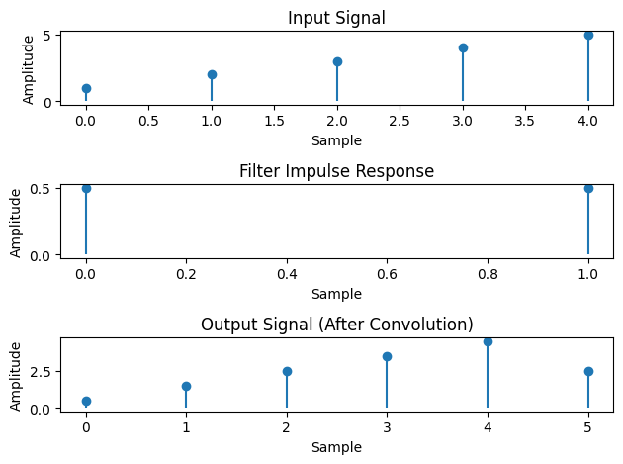
Figure 1.1. Example of convolution process and result

Another example pulled from wikimedia, such that
https://upload.wikimedia.org/wikipedia/commons/6/6a/Convolution_of_box_signal_with_itself2.gif

Reference:
Weisstein, E. W. (2003). Convolution. https://mathworld. wolfram. com/.

2. Image Processing with OpenCV
Before you explore convolutional neural networks with images, you can use image processing techniques to understand the pre-processing and processing part of the convolution or feature extraction layer in CNN.

For now, only colour thresholding will be introduced as the root information of all pictures are the RGBA or HSV data.
The rest such as edge detection, shading thresholding, e.t.c. can be studied by oneself.

Before understanding colour thresholding, let us discuss the general convention of colour representation in the digital world.

Understanding 1: Features: BGR representation in a single pixel
In general, you can represent a single pixel with 3 channels of blue, green and red; hence BGR. Each pixel just says how much the pixel has blue, green or red in the range of 0 to 255. We all know that mixing blue and yellow will result in a green. Similarly for example, the colour cyan or hex #00FFFF has BGR values of B:100, G:100, R:0 or it has a mixture of 100 values of blue, 100 values of green and 0 values of red. The following table shows general convention and functions of BGR, A, and HSV.

Table 2.1. Commonly used models (RGBA and HSV) and their representation
Name | Represent | Explanation
Blue | B | Determines the intensity of blue colour in the range of 0 to 255
Green | G | Determines the intensity of green colour in the range of 0 to 255
Red | R | Determines the intensity of red colour in the range of 0 to 255
Alpha | A | Represents the transparency or opacity of the colour  Range from 0 (fully transparent) to 255 (fully opaque)
Hue | H | Represent dominant wavelength of the colour  Measured in degrees of 0 to 360 (defines basic colour such as red, green, blue, etc)
Saturation | S | Indicates purity or intensity of the colour  Ranging from 0 to 1, 0 meaning greyscale, 1 meaning vibrant or pure colour.
Value (Brightness) | V | Determines the brightness or intensity of the colour  Ranging from 0 to 1, 0 represents black, 1 represents brightest possible colour

Pictures are 2D arrays containing data of each pixel. Example as shown in Figure 2.1. and Table 2.2.

Figure 2.1. Example of a 4 by 4 Image

Table 2.2. Example of image in Figure 2.1 in the form of 2D array where elements are the RGBA data
RGBA:(255,0,0,255) | RGBA:(0,0,255,255) | RGBA:(255,255,0,255) | RGBA:(0,255,0,255)
RGBA:(166,77,121,255) | RGBA:(61,133,198,255) | RGBA:(106,168,79,255) | RGBA:(204,0,0,255)
RGBA:(230,184,175,255) | RGBA:(201,218,248,255) | RGBA:(255,242,204,255) | RGBA:(234,209,220,255)
RGBA:(91,15,0,255) | RGBA:(32,18,77,255) | RGBA:(76,17,48,255) | RGBA:(127,96,0,255)

The picture in Figure 2.1. is a 4 by 4 picture, has 16 features aligned in a 2D array with 4 rows by 4 columns. It is converted to a 2D array representation as shown in Table 2.2. With 4 channels of red, green, blue and alpha (alpha being the opacity of the colour). Notice that Figure 2.1. is just a table.

Understand that each pixel in an image is also called a feature. The 3 colour pixels of BGR are also called features. The grey shading value of a grey-converted image is also called a feature.
Feature is a specific characteristic or property of an image that is detectable and recognisable as something of value or meaning, and can be extracted and analysed.

Features can be colours, edges, corners, textures, histogram of oriented gradients (HOG), SIFT (scale-invariant feature transform) and SURF (Speeded-Up Robust Features). We will eventually introduce more features and techniques with increasing complexity of algorithms, and we start with only colours and edges for brevity.

Reminder: Always make sure you are working with the same RGB format throughout your whole model. There are RGB, RGBA, BGR, HSV, etc. You can use format conversion techniques, such as RGB2BGR in the OpenCV library.

Understanding 2: Filter
In signal processing, a filter is a process of removing unwanted components or features from a signal. The following example in Figure 2.2. shows the filter system that filters the troughs of a sine wave (essentially a half-rectifier).

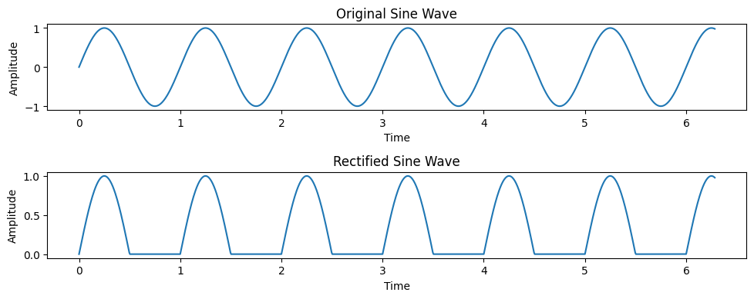
Figure 2.2. Signal processing filter

Masks in colour thresholding and CNN works similarly where it removes components or features that are not desired but the other description is such that it will highlight the parts where you want (via label) and remove what is not needed in the process.

Filters can be used to remove what you don’t want.
Filters can be used to highlight what you want.

Colour Thresholding
Similarly as mentioned above, the filter in colour thresholding can be a single value or a range / spectrum, of acceptable or to be filtered out.

Example we have a picture with black background, a red circle, a blue rectangle and a yellow triangle.

The first filter is such that it only allows red colour in output. The result will be as shown in Figure 2.3.
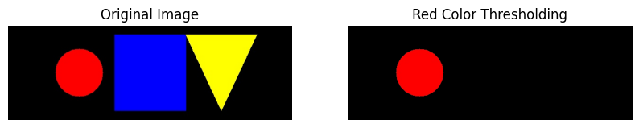
Figure 2.3. Red only colour threshold filter

In the second filter, it is such that it only allows triangles in output (via Canny edge detection technique)
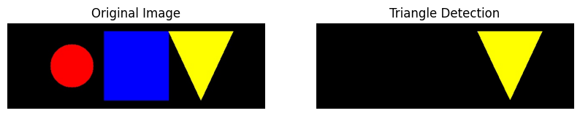
Figure 2.4. Triangle only shape filter

The same can be used for hue, saturation and shading value. Refer to the codes for more intricate details.

3. What is Convolution in Image Processing?
CNN is usually used on image processing tasks.
CNN is such that convolution layers are added to the model at the input stage, prior to the ANN model as shown in Figure 2.1.

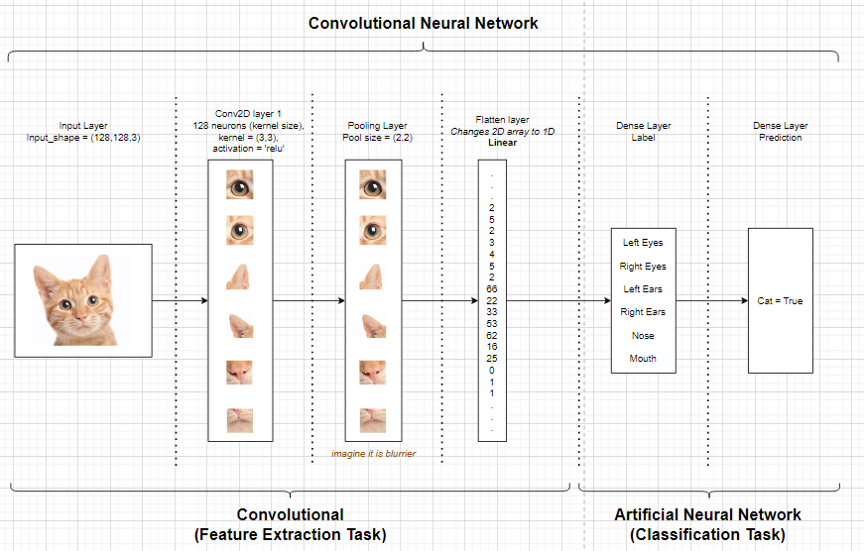
Figure 2.1. Convolutional Neural Network general graph

Remember that each pixel in an image is also called a feature. Convolution in Image Processing is such that the 2D array of the features are convolved with a kernel or mask or filter or a 2D array of weights. This document will refer to the kernel as a 2D array of weights.

Labels
Labels are the most important part in training a supervised learning machine. For example in document ANN basics, the labels are simply the output data and the train input data. However, pictures that are used for most if not all cases of computer vision, must be manually labelled by the user. The labels are the training data for the model to learn. The labels are different depending on how the model wants to learn and which task (as mentioned in Chapter 1) will the model fulfil.

We will discuss preprocessing and techniques to label, after understanding what happens in a CNN model first.

For now, think that our training data are already labelled and our kernels can start learning.

Kernel / Mask / Filter

The kernel is an array of predetermined size (x, x) where x= 2, 3, 4,... containing weights for each of the element slots.

During training in each epoch, this kernel will be updated based on the label and input training images.

Example:
Kernel 1 in epoch 1:

0 | 0 | 0
0 | 0 | 0
0 | 0 | 0

Kernel 1 in epoch 2 (if training works well):

0.2 | 0 | 0
0.3 | 0.5 | 0.4
0.6 | 1.0 | 0

As the name suggests, the kernel is a filter. It is used to determine a certain feature that is desired (known by a label provided by the user).

Note that for object classification tasks without localisation (label via name of directory only), the weight will simply learn the whole input image. These are used for tasks such as to detect whether the image has a cat or not, such that the training data can be named as shown in Table 3.1

Table 3.1. Example data representation for data without localisation
Folder name | train/data/cat/ | train/data/nocat/
Image name within folder | 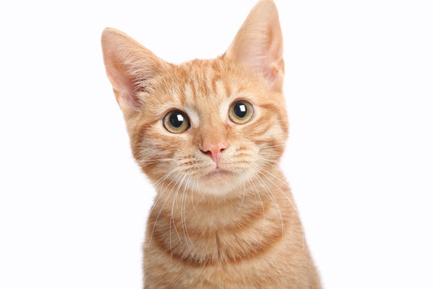  001.jpg | 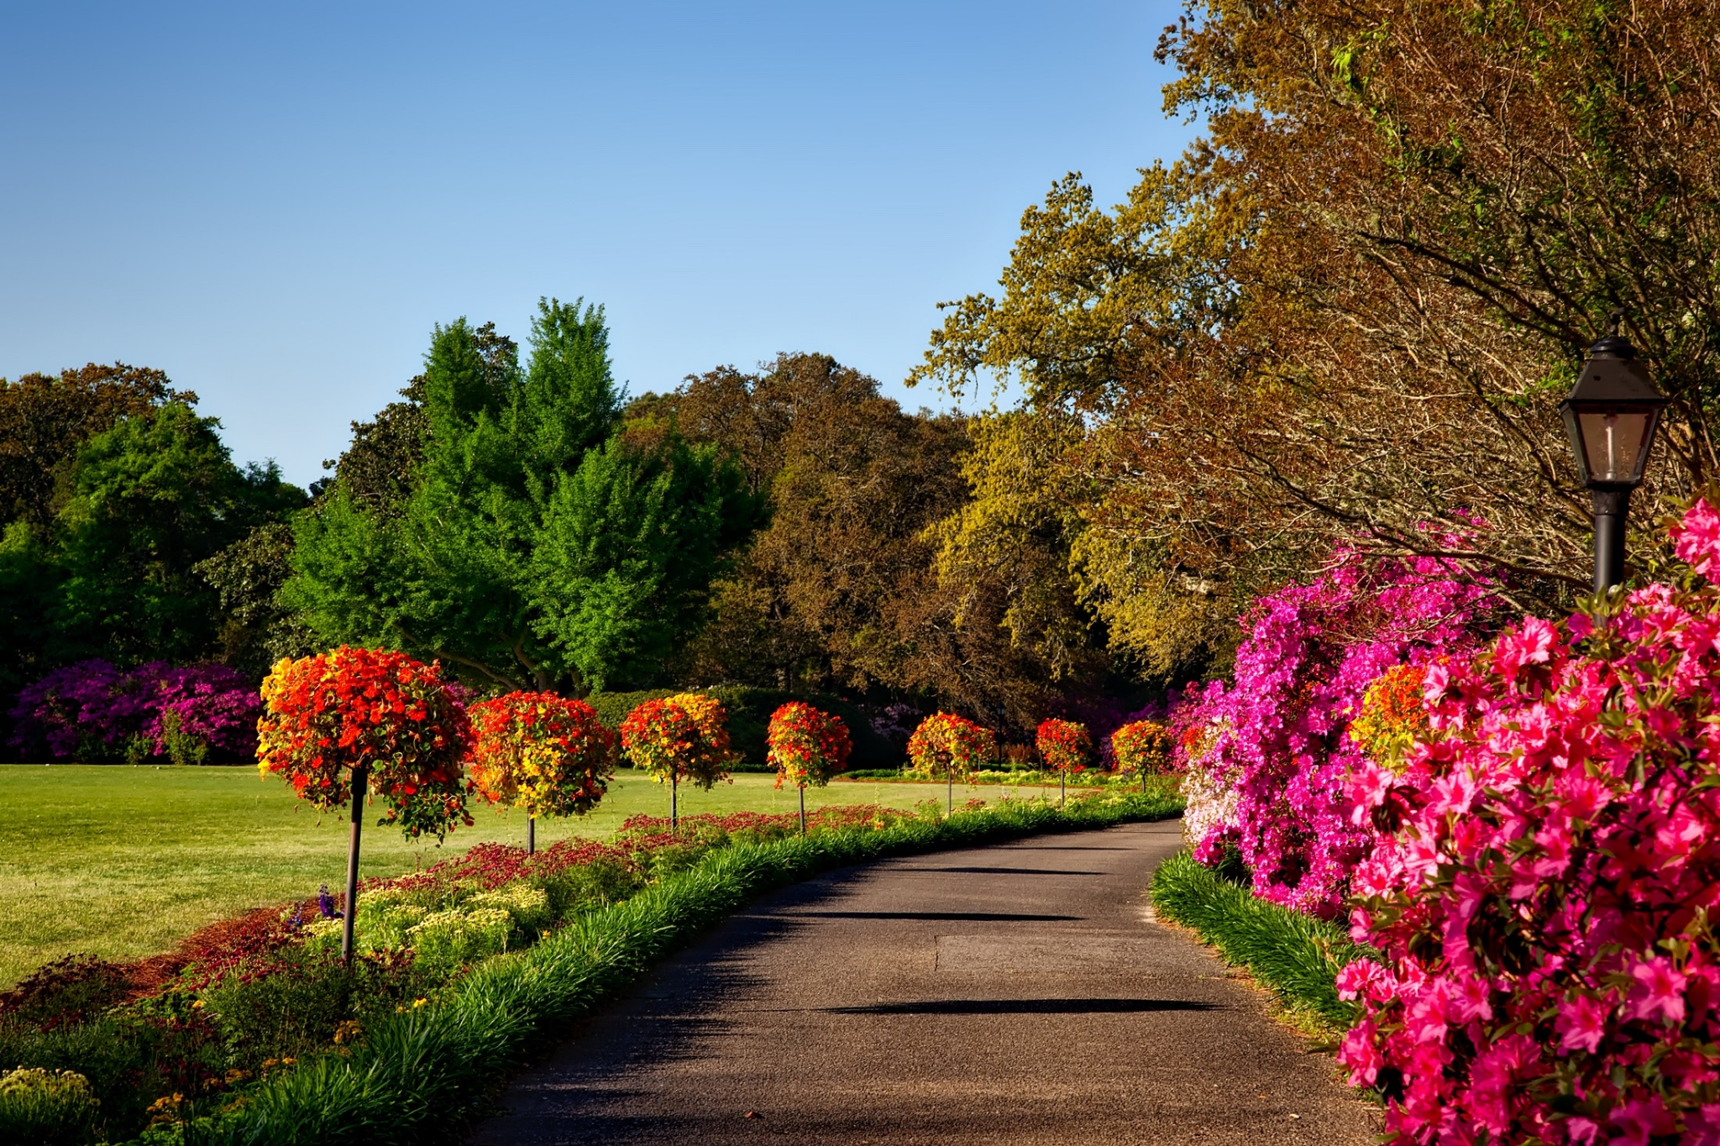  001.jpg

Remember that the data is also represented depending on how you define it (Not necessarily a rule as long as you are the one who programmed the model; if you use pre-determined model such as YOLO, you will have to follow their rules)

In case of training data with localisation. The labels are drawn by the user. Example with a picture of a cat, and the training label for that image is such that,
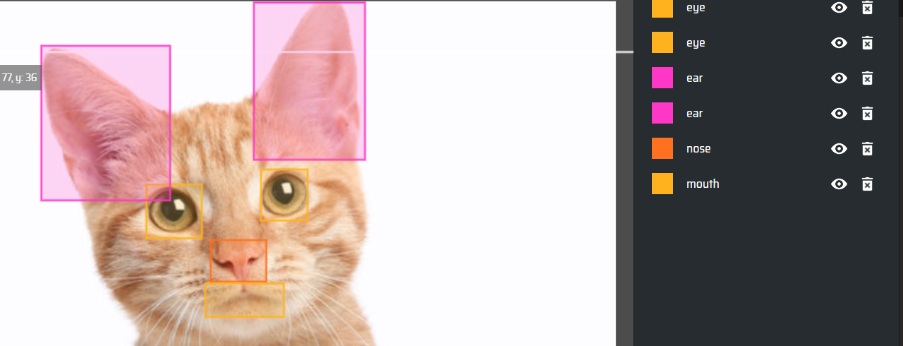
Figure 3.1. Labelling of a cat picture

The weights or kernels will learn the pixels (features) of the cat as labelled where the label position is determined from the position of the image array, denoted as (x, y).

Post training, the kernel will act as a filter, to determine if the image has some feature that fits into the mask. This is why we require a huge amount of data to allow our weights to learn and behave as we desire; converge to a best fit representation of the feature.

Convolution 2D (Conv2D)
We begin our CNN with a convolution layer, usually after preprocessing the data. In Keras, the Conv2D is an easy way one can initiate a convolution layer.

The Conv2D initiation requires the parameters of (no_filter, kernel_size, activation, input_shape
- No_filter is equivalent to number of weights in a single layer in ANN
- Kernel_size is self-determined, usually has a square shape or same number of row and column
- It has activation function post calculating the convolution
- It requires the input shape which is usually denoted as (width, height, channels), channels meaning colour such as BGR (3 channels) or black and white (1 channel)

There are 2 types of correlation in convolution which are Full correlation and Half correlation.

Full correlation is such that it considers possible overlapping positions and requires padding to maintain the input size. The output size is usually larger than that of half-correlation

Half correlation is such that it only considers the position where the kernel remains fully contained and does not require padding, resulting in a smaller output size.

Half-Correlation

Kernel
Example calculation of Conv2D is shown below, given the data is a simple binary coloured data. Initiation of the kernel is also random.

1 | 1 | 1 | 0 | 0
0 | 1 | 1 | 1 | 0
0 | 0 | 1 | 1 | 1
0 | 0 | 1 | 1 | 0
0 | 1 | 1 | 0 | 0
Input image

1 | 0 | -1
1 | 0 | -1
1 | 0 | -1
Kernel1

The convolution of the kernel and the image data is such that the kernel will move at every interval tuned by the user, as the kernel is always smaller than the image, whether it is to learn intricate details or to save resources. You can think of the position of the kernel as the same with (x, y) and movement of the kernel across the image is called “stride”. Stride 1 will always occur at position (0,0) unless told otherwise.

Stride 1: * kernel

1 | 1 | 1 | 0 | 0
0 | 1 | 1 | 1 | 0
0 | 0 | 1 | 1 | 1
0 | 0 | 1 | 1 | 0
0 | 1 | 1 | 0 | 0
Part of Input image used for Stride 1 calculation

Stride 1 output: (Element-wise multiplication, not a dot-product), np.array achieve by array1*array2
Green colour being the kernel and blue colour being the data from the image, previously coloured black.

1 | 0 | -1 |  | 1 | 1 | 1 |  | 1*1 | 0*1 | -1*1 |  | 1 | 0 | -1
1 | 0 | -1 | * | 0 | 1 | 1 | = | 1*0 | 0*1 | -1*1 | = | 0 | 0 | -1
1 | 0 | -1 |  | 0 | 0 | 1 |  | 1*0 | 0*0 | -1*1 |  | 0 | 0 | -1
Stride 1 Calculation pre-sum

The new kernel 1 output or updated first stride is the sum all the elements of the rightmost array,
1 + -1 + -1 + -1 = -2. Coloured in black in the updated kernel1 array.

-2 | 0 | -1
1 | 0 | -1
1 | 0 | -1
Output in stride1

–––––––––––––––––––––––––––––––––––––––––––––––––––––
Next, Stride 2

1 | 1 | 1 | 0 | 0
0 | 1 | 1 | 1 | 0
0 | 0 | 1 | 1 | 1
0 | 0 | 1 | 1 | 0
0 | 1 | 1 | 0 | 0

Part of Input image used for Stride 2 calculation

1 | 0 | 0 |  | 1 | 1 | 0 |  | 1*1 | 0*1 | 0*1 |  | 1 | 0 | 0
1 | 0 | -1 | * | 1 | 1 | 1 | = | 1*1 | 0*1 | -1*1 | = | 1 | 0 | -1
0 | 0 | -1 |  | 0 | 0 | 1 |  | 0*0 | 0*0 | -1*1 |  | 0 | 0 | -1
Stride 2 Calculation pre-sum

-2 | 0 | -1
1 | 0 | -1
1 | 0 | -1
Output in stride2 (f

The new kernel 1 at position (0,1) is the sum all the elements of the rightmost array,
1 + 1 + -1 + -1 = 0
So on and so forth until the end of the stride.

The end product of the output is called feature map

Padding And Stride
The stride number of the example shown in the kernel is 1,1.

Padding adds extra border pixels to the input data (Is not shown in this document)
Stride determines the step size of the kernel as it slides over the input. Larger stride value reduces spatial dimensions of output feature map

Stride 1,1 means there is no skipping of next stride pixels happening. Let us look at how stride = 2,2 or 2 row, 2 col will look like.

1 | 1 | 1 | 0 | 0
0 | 1 | 1 | 1 | 0
0 | 0 | 1 | 1 | 1
0 | 0 | 1 | 1 | 0
0 | 1 | 1 | 0 | 0
Stride 1

1 | 1 | 1 | 0 | 0
0 | 1 | 1 | 1 | 0
0 | 0 | 1 | 1 | 1
0 | 0 | 1 | 1 | 0
0 | 1 | 1 | 0 | 0
Stride 2

1 | 1 | 1 | 0 | 0
0 | 1 | 1 | 1 | 0
0 | 0 | 1 | 1 | 1
0 | 0 | 1 | 1 | 0
0 | 1 | 1 | 0 | 0
Stride 3

1 | 1 | 1 | 0 | 0
0 | 1 | 1 | 1 | 0
0 | 0 | 1 | 1 | 1
0 | 0 | 1 | 1 | 0
0 | 1 | 1 | 0 | 0
Stride 4

As observed, the second stride will skip 1 pixel as the stride steps are 2 columns and 2 rows. More accurately, stride steps = 2 columns means it will + 2 to the current position. Reminder that the position of the arrays are as shown

(0,0) | (0,1) | (0,2)
(1,0) | (1,1) | (1,2)
(2,0) | (2,1) | (2,2)

Note that the convolution method used here is formally called half-correlation.

Full-Correlation
Full-correlation is such that the convolution operation considers all possible overlapping positions between input and kernel.
The output size is also larger than that of half-correlation as the kernel can extend beyond the boundaries of the input.
To accommodate the larger output size, padding is often added to the input

Example of Full Correlation is as such. Given the same picture and kernel as above, the first stride will look as such,

1 | 1 | 1 | 0 | 0
0 | 1 | 1 | 1 | 0
0 | 0 | 1 | 1 | 1
0 | 0 | 1 | 1 | 0
0 | 1 | 1 | 0 | 0
Input image

1 | 0 | -1
1 | 0 | -1
1 | 0 | -1
Kernel1

Firstly, the image is padded with 1 pixel to all directions, as shown in red

0 | 0 | 0 | 0 | 0 | 0 | 0
0 | 1 | 1 | 1 | 0 | 0 | 0
0 | 0 | 1 | 1 | 1 | 0 | 0
0 | 0 | 0 | 1 | 1 | 1 | 0
0 | 0 | 0 | 1 | 1 | 0 | 0
0 | 0 | 1 | 1 | 0 | 0 | 0
0 | 0 | 0 | 0 | 0 | 0 | 0

The first stride will occur as below,

0 | 0 | 0 | 0 | 0 | 0 | 0
0 | 1 | 1 | 1 | 0 | 0 | 0
0 | 0 | 1 | 1 | 1 | 0 | 0
0 | 0 | 0 | 1 | 1 | 1 | 0
0 | 0 | 0 | 1 | 1 | 0 | 0
0 | 0 | 1 | 1 | 0 | 0 | 0
0 | 0 | 0 | 0 | 0 | 0 | 0

And so on

Function of Convolution Layer
The function of a convolution layer is such that,
- Feature extraction
- Using the filter or mask or kernel to extract desired features.
- The features can represent edges, textures, shapes, or complex structures and the base of these features are colours or brightness, etc. depending on representation.
- Dimensionality reduction
- As observed by the output of each stride, the dimensionality of the input data
- Parameter sharing
- Each filter in convolution layer is applied to the entire input feature map
- Same set of filter weights is used at every spatial position in the input
- Reduces the number of parameters compared to fully connected layers, making CNN more efficient and capable of learning translation-invariant features
- Allows CNN to detect the same features regardless of its position in the input
- E.G. As long as the dog has 2 eyes, 2 ears, 1 nose, 1 mouth, regardless of the position of the dog in the image, the CNN model will still know if a dog is present in the image.
- Spatial Hierarchy
- Creates a spatial hierarchy of features
- Initial layers capture the low-level features (such as edges and corners), while deeper levels learn more complex and abstract details (E.G. An eye, then shape of the eye)
- This hierarchical representation enables CNN to learn increasingly sophisticated representations of the input data, leading to better discrimination and understanding of the underlying patterns.
- Learning Hierarchical Representation,
- By stacking multiple layers of CNN, the model will be able to learn the hierarchical representations of the input data.
- Local receptive field:
- Convolution layer operates on a small local regions of inputs (known as receptive field)
- By focusing on local regions, the convolution layers can capture spatially related patterns and exploit the locality of information in input data.
- Allows the network to learn hierarchical representations of increasing complexity as layers progress.
- Examples such as the position of a dog’s nose must be above the mouth and below the eyes, at least in normal conditions.
- Nonlinear Activation
- After convolution operation, nonlinear activation function can be applied to further introduce nonlinearity into the network.

Pooling Layer
After completion of Conv2D, the output of the convolution layer will be sent to a layer called “Pooling layer”.

Pooling layer is used to,
- Further reduce spatial dimension - via Downsampling to focus on relevant features
- Translate Invariance - Helps network to be less sensitive to small shifts or translations in the input data (reduce overfitting)
- Make computation more efficient - By reducing the jumper of parameters

Conventionally, Max Pooling and Average Pooling are done.

Maximum Pooling
Remember that the output image is also a 2D array of image. Example as shown in Figure 3.2.

0 | 1 | 2
3 | 4 | 5
6 | 7 | 8
Figure 3.2. An example image of 3 by 3

And that the pooling size is (2,2). Therefore during the first iteration, only the following positions of the figure will be considered.

0 | 1 | 2
3 | 4 | 5
6 | 7 | 8

During maximum pooling, only the largest value from this 2 by 2 array will be taken such that the output of this will be

4
Second iteration,

0 | 1 | 2
3 | 4 | 5
6 | 7 | 8

4 | 5
Third iteration,

0 | 1 | 2
3 | 4 | 5
6 | 7 | 8

4 | 5
7
Final iteration,

0 | 1 | 2
3 | 4 | 5
6 | 7 | 8

4 | 5
7 | 8
Hence, the output of the layer is

4 | 5
7 | 8

Average Pooling

Average pooling takes the sum of the elements within the array, then divide by the number of elements

0 | 1 | 2
3 | 4 | 5
6 | 7 | 8
Figure 3.2. An example image of 3 by 3

And that the pooling size is (2,2). Therefore during the first iteration, only the following positions of the figure will be considered.

0 | 1 | 2
3 | 4 | 5
6 | 7 | 8

During average pooling, the average value of the 4 elements will be taken such that the output of this will be
$Y = (0+1+3+4)/4 = 2$

2
Second iteration,

0 | 1 | 2
3 | 4 | 5
6 | 7 | 8

$Y = (1+2+4+5)/4 = 2$

2 | 3
Third iteration,

0 | 1 | 2
3 | 4 | 5
6 | 7 | 8

$Y = (3+4+6+7)/4 =5$

2 | 3
5
Final iteration,

0 | 1 | 2
3 | 4 | 5
6 | 7 | 8

$Y = (4+5+7+8)/4 =5$

2 | 3
5 | 6
Hence, the output of the layer is

2 | 3
5 | 6

4. How is Convolution Neural Network trained?
Chapter 3 discusses the usage of convolutional neural network; post-training. But how do we train CNN? It is exactly the same with Chapter 3, except we have back-propagation, similar to what happens when training an ANN model.

Remember from ANN the basic calculation of forward propagation is such that
$Y=X*W + B$
Where Y = output, X = input, W = weight and B = bias.

Similarly in CNN,
$Y=X*K+B$
Where K = kernel.

Remember that to train a neural network in backpropagation step, the derivative of loss with respect to the weight and bias is calculated such that,
$Y=X*K + B$

And for a single data point, the loss function of categorical_crossentropy is such that
$L = -\sum{}(y_{true}*log(y_{pred})$
In CNN, the final output layer usually has its neurons activated via softmax activation function.
Softmax is used to convert a vector of real numbers into a probability distribution over multiple classes,
$Softmax,P(Y) =\frac{e^{Y_{i}}}{\sum_{j}^{n}{}e^{Y_{j}}}$
Now the loss function becomes
$L = -\sum{}(Y*log(P))$
Substitute Y = X*K + B and Softmax’s P(Y) function to obtain the following function for updating kernels (weights)
Reminder:

$\frac{∂L}{∂K}=X*\frac{∂L}{∂Y}$

Considering the fact that the CNN model we are working with calculates in 2D matrices, the weight or kernel’s gradient function becomes
$\frac{∂L}{∂K_{ij}}=X_{j}*\frac{∂L}{∂Y_{i}}$
While the bias’ gradient is
$\frac{∂L}{∂B_{i}}=*\frac{∂L}{∂Y_{i}}$
And the actual output Y function is such that,
$Y=B_{i}+\sum_{j=1}^{n}{}X_{j}*K_{ij}, i=1...d$

Finally, update the kernel and bias using gradient descent as usual.

Kernel -= learning_rate * gradient_kernel
Bias -= learning_rate * gradient_bias

Reminder: The Softmax activation function is useful for multi-class categorisation tasks but it is not the only activation function that can be used for CNN models. Example a binary classification (e.g. cat and dog) CNN model can use binary cross-entropy and sigmoid activation function. Binary cross-entropy is simply categorical cross-entropy but only 2 classes.

Reference: https://www.youtube.com/watch?v=Lakz2MoHy6o

5. Types of CNN tasks with image and video
CNN tasks can be classified into different types
- Object Recognition
- Object Classification
- Object Detection
- Object Segmentation (Instance and Semantic)

The following figure summarises the object recognition of computer vision task
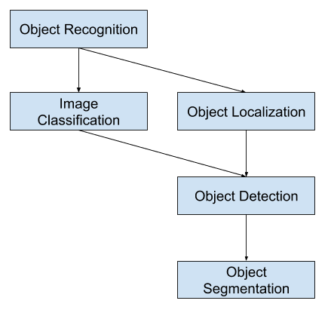
Figure 1.1. Overview of computer vision task for object detection
Image obtained from: https://machinelearningmastery.com/object-recognition-with-deep-learning/

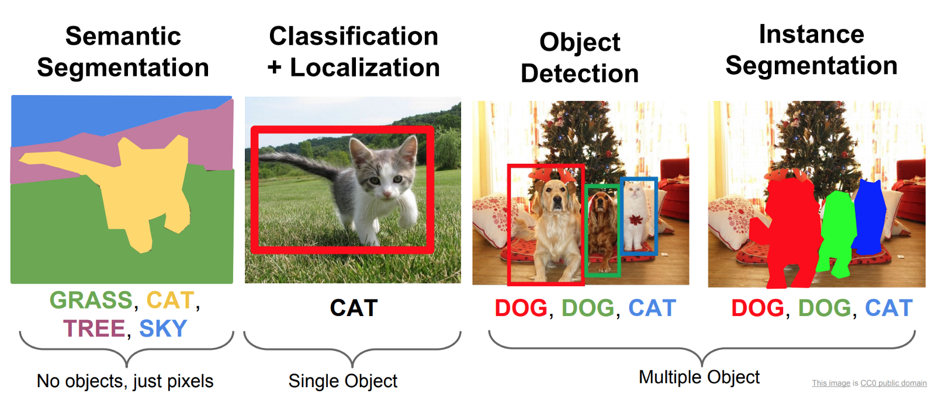
Figure 1.2. Object Classification, Object Detection, Semantic segmentation, and Instance Segmentation
Image obtained from:
https://analyticsindiamag.com/top-5-image-classification-research-papers-every-data-scientist-should-know/

There are Object classification variations that do not require labelling (is simply called “Object Classification” without Localisation. Localisation is such that the bounding box is drawn around the actual object itself.

Single Target |  |  | Multiple Target
Object Recognition | Object Classification | Object Classification + Localisation | Object Detection | Instance Segmentation | Semantic Segmentation
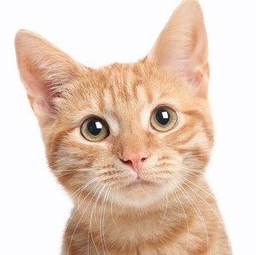  data/train/cat/001.jpg |   data/train/cat/001.jpg | 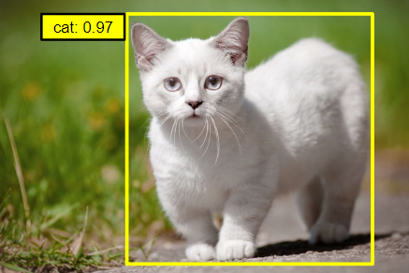  data/train/cat/001.jpg  “0.97” is confidence point | 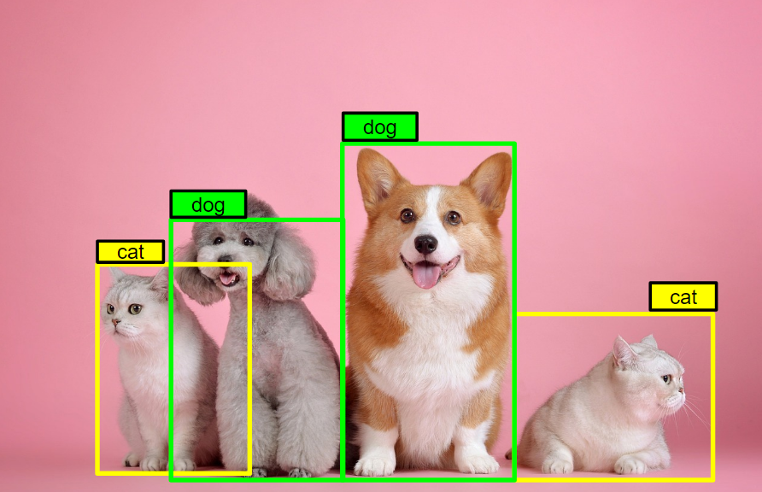  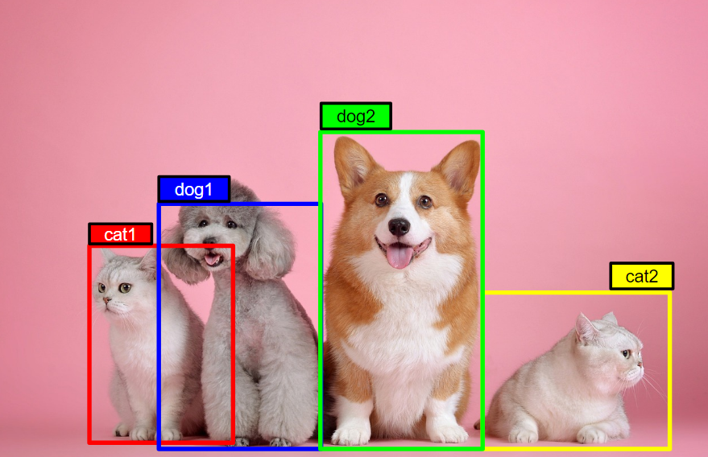 | 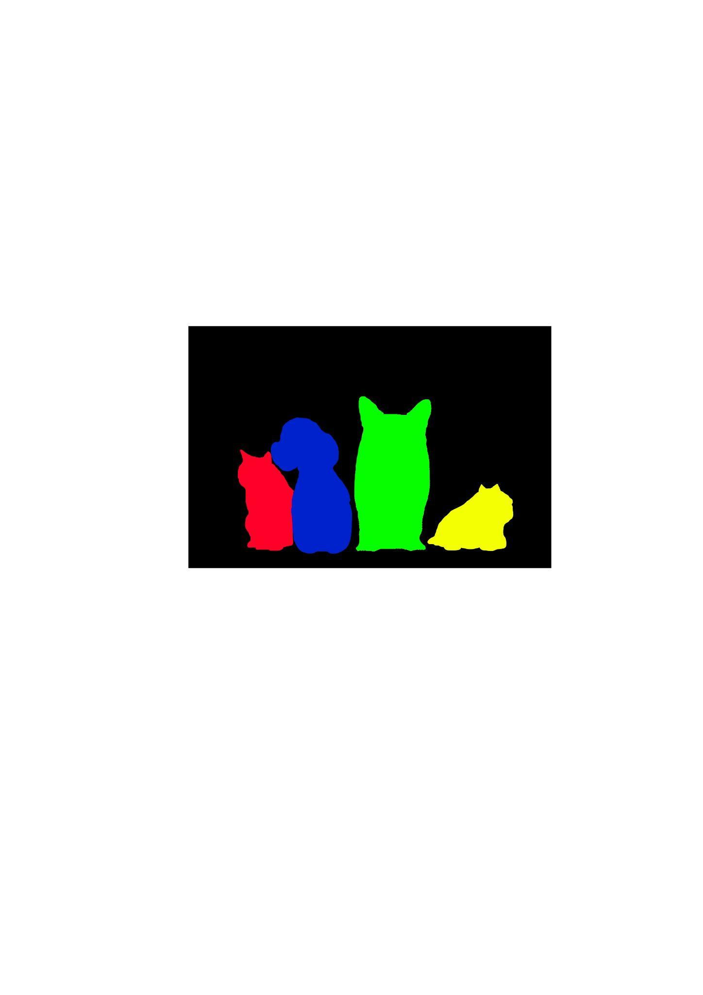 | 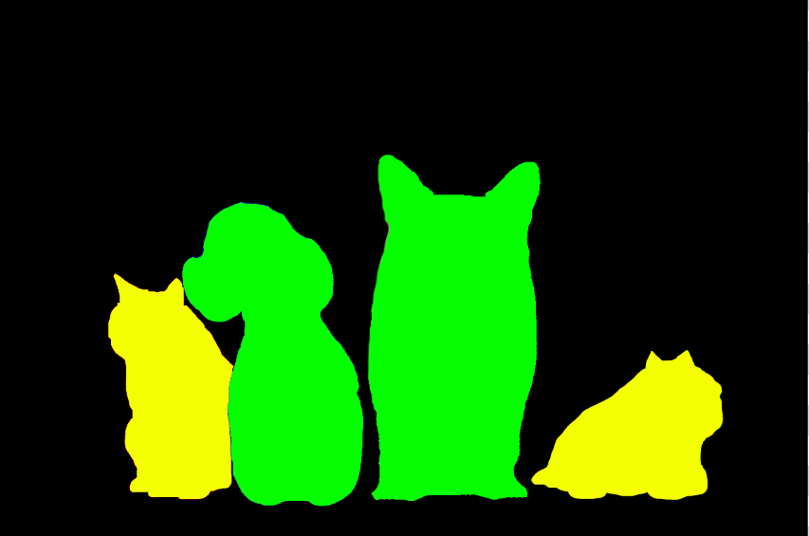
“This is a cat” | “Cat” | “Cat” |  | Dog1, Dog2, Cat1, Cat2, Background | Cat, Dog, Background

Instance segmentation is able to differentiate objects of similar classes but different objects (Dog1, Dog2), while Semantic segmentation will not be able to differentiate them (will both classify as “Dog”)

Finally
Finally you can go through this video:
Convolutional Neural Network from Scratch | Mathematics & Python Code by The Independent Code
https://www.youtube.com/watch?v=Lakz2MoHy6o

Refer to the code at the end as there are extra details on training a simple CNN model on MNIST dataset from Kaggle. Kaggle is a data science competition platform and online community of data scientists and machine learning practitioners under Google LLC. It has competitions, communities, datasets, models, etc.
The Google Colab notebook attached with this document:
https://colab.research.google.com/drive/1aEweHIlGpcIUFYXUPQ3NN3EByWW80pYV?usp=sharing

Kaggle:
https://www.kaggle.com/

